The Journey of an agripreneur :Samir Ranjan Bordoloi , Assam
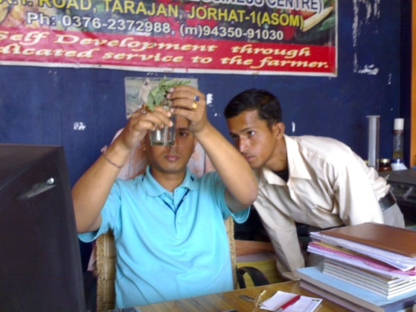
Being a graduate from Assam Agricultural University , I was offered a job of Agricultural Extension Officer in the Govt. of Arunachal Pradesh . But with the urge to get more exposure to farming practices of different parts of the country , I joined Rallis India Limited (a Tata enterprise ) in their agrochemical division and was posted at Jorhat in Assam which exposed me to lots of farmers of Upper Assam. With some qualitative training programmes on self development , I built a strong confidence in me to start something at my own to serve farmers of my area as already they were pushed to monocropping of tea and lots of chemicals and fertilizers making their village life amidst cocktail of chemicals. That urge gave birth to my first venture SS Botanicals ,an agri clinic and agribusiness centre in the year 2003. Trained under MANAGE , Hyderabad with ISAP , Guwahati ,I was supported by State Bank Of India and Indian Bank to reach more and more farmers and serve them towards Organic farming initiatives. I could reach more than 20000 farmers through my clinic and introduced the concept of Krishok Bandhu Help Card making the farmer a member of the clinic and offering them profit making and value-added services. Plant health clinic providing organic solutions , soil testing , developing agro tourism ventures , publication of farmer’s monthly magazines like Prakriti and Seuj Chinta , forward &backward linkage development were the activities done under SS Botanicals. With MANAGE , Hyderabad providing me hand-holding support and promoting my works in different platforms , the demand for my services were increasing and I thought it was the time to diversify with innovative ideas.
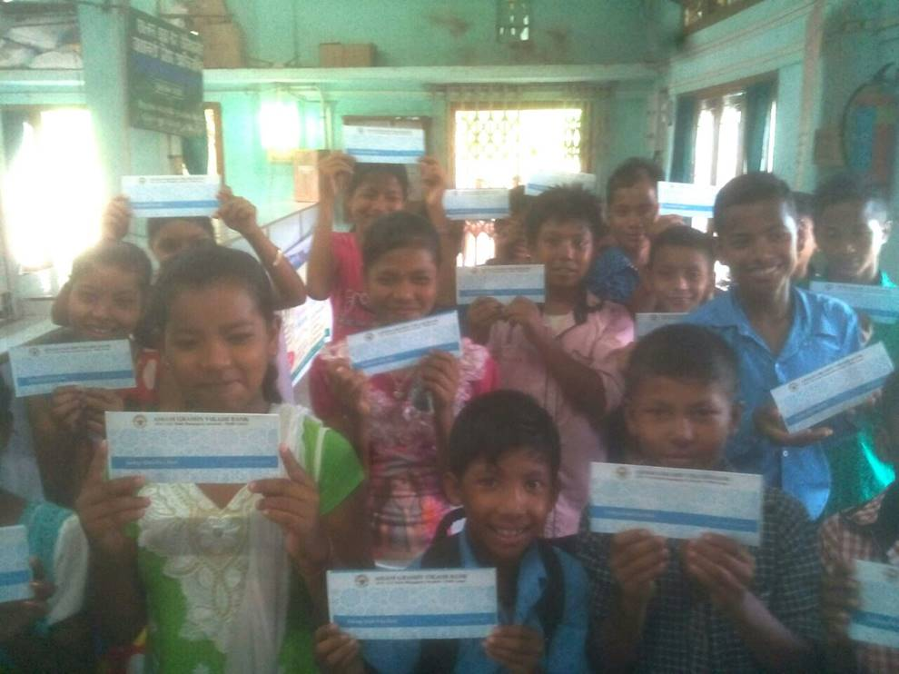
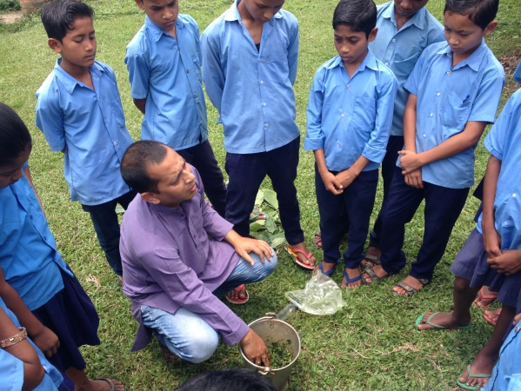
In the northeast part of India , I identified two strengths of us to build up our entrepreneurship and that is our Natural Resources and the Hospitable nature of our people. So I decided to promote Organic farming with all the natural resources we have and promote agro tourism together to sustain our farmer’s income in the region. Creation of Entrepreneurship by introduction of lifeskills and financial literacy was so important with the farming activities for the farmers to create dream and vision in them . That resulted in becoming a part of Farm2Food Foundation along with a friend Deepjyoti Sonu Brahma , an education expert and an Ashoka fellow to combine both my organic farming skills with natural resources and his educational skills including Lifeskills to strike at schools and colleges at Village level to create Farm-Preneurs among the childrens of farmers. At Farm2Food Foundation , we aim at creating Farm and Food entrepreneurs among rural unemployed youths by showing them farming techniques taking Nature as the capital to make the Northeast peaceful and prosperous. My experience of working with school children in rural Assam introducing soft skills of organic farming like vermicomposting , school organic nutrition garden and opening bank accounts led to the launch of a flagship programme called ‘Farm preneur’ in 150 rural Govt. schools of Assam. The agricultural extension technique which I developed through the farmer’s children in rural schools proved to be successful also in motivating communities to take up organic agricultural practices. An example of this is the South West Jorhat Vermicompost Growers Cooperative society in Jorhat where 150 kids in Chirtralekha Shiksha Bikash Mandir took up Thermokol box vermicomposting and carried the technology to the community. On 7th of March,2016 the Chief General Manager , NABARD visited the school and the communities and now planning bigger movement with the bank to replicate the model in creation of FPOs. Most of the parents who are farmers were practicing chemical farming and the efforts of the kids led them to organic and in last three months , the group sold vermicompost , earthworms , vermiwash worth 6.45 lakhs INR to MD’s Organic Farm. This year I am working with 3000 school children in 150 Govt. Middle English Schools with the support from Assam Sarva Shiksha Abhiyaan. Under Farm preneur programme , 20 students FP club is formed in each school and the students make vermicompost and a 1000 sqr ft Bio intensive raised bed farming school nutrition garden where they grow local nutritious vegetables and sale them to the headmasters for Mid Day Meal scheme. They also sale vermicompost , vermi wash and earthworms to tea gardens and deposit the money to their bank accounts opened under the programme. Its an activity based learning where the students can explore with whatever taught in their textbooks.
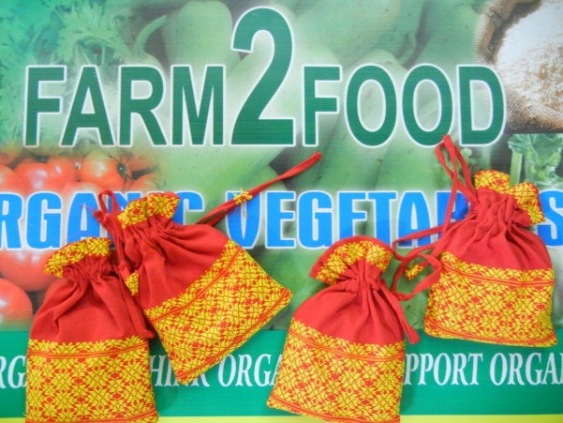
Local seeds and indegeneous crops are the strength of the region and last year I developed packaging and marketing of hand made organic green tea and herbal tea like rosella and even exported it to countries like Canada and France through fair trade. The packagings were developed with local resources like the traditional assamese gamosa and bamboo materials. A farm learning centre and an agrotourism centre is being developed at Merapani in the foothills of Nagaland and developing it for a medicinal plants of Assam learning centre replicating the model of MAP plants nursery suggested by Late APJ Abdul Kalam in his book Vision 2020. Now, through lots of tie-ups with like-minded organization I am increasing my services to different parts of the Northeast like Nagaland , Manipur and Meghalaya .
I am working with more than 200 young farmers showing them the path of profitable farming through usage of natural resources in farming reducing the input cost . Last year I developed the model of bamboo made raised beds which gives a very good lesson to youths about profit making in agriculture means planning your garden not having huge lands for farming. In my organic farm I made a model of the raised bed of 4ft*10ft (40 sqr ft) area and planted 40 plants of local chilli variety (high density planting) which yielded me 510 kgs of chilli sold at 40INR per kg giving me 20400INR from one bed . So, now with 50 youths of a village in Golaghat distrivt we are making Homestead development programme with those beds and creating the village Charaimari into a model village.
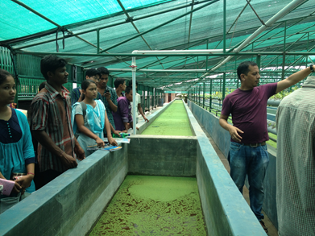
I have developed the Northeast’s biggest hitech organic farm MD’s Organic farm and Learning Centre at Jorhat where we have combined efforts of production and training. The model is made with the aim of addressing future biggest problems of the area : Soil Health and Water Scarcity. The farm has 250 cows belonging to Indian breeds Rathi and Gir and producing 800 litres of milk everyday which are processed to sweets. The farm has a vermicompost unit which produces 600MT of vermicompost per year.The azolla unit produces 100 kgs azolla everyday which are fed to the cows. Organic green vegetables are produced under protected cultivation and sold at the farm retail outlet. The farm has become a training and exposure visit purpose for organization like AAU , NABARD and Department of Agriculture and NGOs. A Farm Learning Centre with the capacity of 50 farmer’s stay with AC dormitory and Conference hall is being under construction.
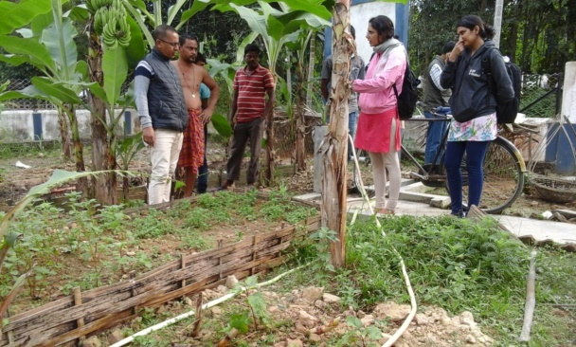
Area covered through consultancy on Natural farming is spreaded over the states of Assam , Nagaland , Manipur and Meghalaya and working with about 5000 farmers in Assam , 300 farmers in Manipur , 150 farmers in Nagaland and 50 women turmeric farmers of Meghalaya. 6 model villages have been created in Assam , one model village in Nagaland and one in Manipur. In 2015-16 a total number of 5800 farmers were trained by me on low cost organic farming methods.15 Farm Learning Centres have been formed in Assam . I am also creating the first Farm Learning Centre in Nagaland at Jalukie village and one in Manipur at Simone village. Employment generation under SS Botanicals is 4 , Farm2Food Foundation is 7 , MD’s Organic Farm 45 which makes a total of 56 people employed directly and lots of people are generating their livelihood through my activities. The qualification of employees varies from skilled rural youths in the farm to MBAs and MSWs and animal health specialists. Developed 3 Agro tourism ventures in Assam.Developed 3 business packages for farmers which are seed to market packages for vermicompost , Rosella and green tea. The activities I took up for self development through services to the farming community rewarded me to win faith of my farmers and I am now representing all the farmers in the prestigious Board of Management of Assam Agricultural University and bagged the 2015 Northeast Social Impact award.
As a Free Lance Extension worker I am being able to support the Agricultural Extension mechanism by supporting it by creating mindset of our farmers to adopt farm entrepreneurship and in the race could lead a comfortable and satisfied life by earning good income following my own passion.From all my activities like the MD’s Organic Farm , SS Botanicals (Agri consultancy services) , Farm2Food Foundation I can earn a respectable amount of about 30 lakhs INR annually.
Future planning is to build on what is made with a programme called Farm-Connect to provide mobile consultancy service and trainings to farmers and link them to the market which may be consumers or Buyers or fellow farmers and build strong Northeast Brand of products.

