Successful Farming technique : Bio Intensive bamboo made Raised Beds – By Samir Ranjan Bordoloi , Agripreneur , Assam , India.
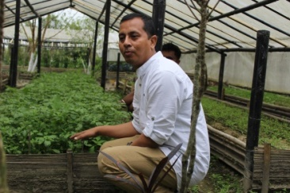
When you explore nature , to find solutions for problems in farming then nature comes out with beautiful solutions .My journey of farming in harmony with the nature is leading to find out many techniques which helps me to make profit in farming economically as well as keeping intact all the farm resources healthy and most importantly not harming the most useful asset of a farmer –the soil . One such method which I am practicing is Bamboo made Bio Intensive Raised beds .
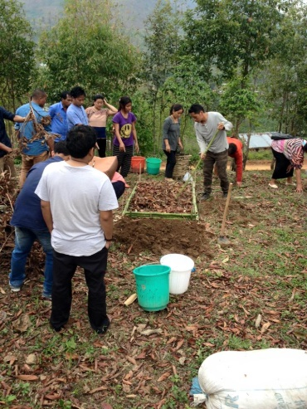
As in Northeast India , we have both the extremes of climate as when its rain its flooded and when no rain it is too dry . So I was searching for some methods to encounter these two extreme conditions in all my farmer’s fields where I was promoting organic farming with all our own resources . The idea came while working at MD’s Organic farm at Jorhat dealing with a low lying area of the farm where rainy season the garden is flooded and the beds are washed away . I believe when God gives us a problem ; he also gives us a solution which is with the nature only . Thus , my eyes found the bamboos growing in the farm and the idea of making raised beds with bamboo which is abundant in the region struck my brain . So started learning about making raised beds and read the book The Sustainable Vegetable Garden : A backyard Guide to Healthy soil and Higher Yields by John Jeavons and Carol Cox . I was impressed by the idea of making Bio Intensive Raised beds with double digging method . As already we were making lots of compost , it is an easy technique for us and now I started to explore how I could match the technique with our local resources . So bamboo is the best resource to make the walls of the raised beds as all farmers here have bamboos in their farm . So first started 20 Bamboo made raised beds with the double digging system in the farm in the year 2014 . Above the ground level the bed was raised to a height of six inches with compost that we made by combining dry leaves and green water hyacinth plants found in abundance in the water bodies of the region . Cowdung slurry mixed with cow urine and jaggery are spreaded over the compost made over the bed . Cowdung ash is applied on the raised bed .Vermicompost made in specially designed bamboo-made tanks with local species of earthworms found in banana pseudostem . Hexagonal spacing system is used on the bed to accommodate more plants on the bed . High density planting is followed and mulching is done with straw or live mulch .
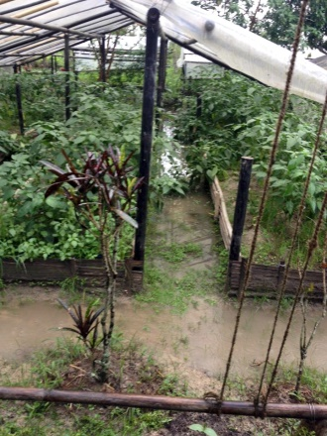
Planting 40 plants of local variety of tomato in 40 square ft . bed could enabled us to harvest 385 kgs of tomato compared to same size of regular bed (not raised ) which could give us 110 kgs of tomato in a comparative study we took up at MD’s Organic Farm . Disease like late blight was not observed in the bamboo made bio intensive raised bed and the conventional bed plants were attacked by the late blight fungus . The raised beds are the best way to encounter floods that occur in the low lying areas of the farm . This year early rain causing flood in the farm but in that situation also the bamboo made raised beds allowed us to save and have good crops . In the same way these beds also help farmers by giving good crop even in moisture stress conditions . The plants that grow in the raised beds are strong enough to encounter any kind of insect pest and disease attacks . The plants on the raised beds have shown more resistance to those insect and diseases compared to general beds . The beds have also proven useful in local seed saving mission . 15 seeds of a traditional purple colour rice variety planted in a raised bed with drip irrigation yielded 1.800 kgs of seeds . This indication led me to adopt a village called Charaimari in Golaghat district to train 70 households to make raised beds with the use of easily available bamboos to cultivate paddy to produce and conserve local varieties of seeds along with developing raised bed nutrition gardens .
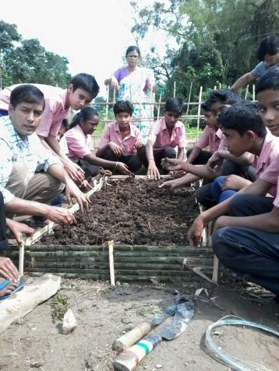
The success of these beds led me to promote Bamboo made raised bed Organic Nutrition gardens in Government schools of Assam through my Organization Farm2Food Foundation’s Farm Preneur programme . Students develop the garden and grows local nutritious greens and consumes them in their mid-day meal . This has also become an extension tool as all parents are farmers and the kids carry the technology to the community . Presently , I am developing them in 150 schools and their communities to take up this method which keeps the soil intact , more production and good food .

MAKING A BIOINTENSIVE RAISED BED:

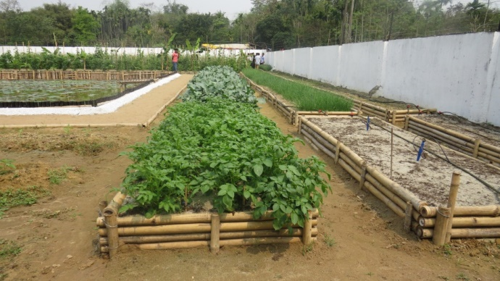
The first step involved in making a garden is to think about the beds : placement , size and arrangement . Depending on the availability of sunshine in the garden we should plan the beds . The beds should be made always in the North-South direction to ensure equal distribution of sunshine . The size and shape of the beds depends on the size of the garden . The minimum size should be at least 3 feet by 3 feet for food production . Paths of the garden should be made keeping in mind that maximum space of the garden is utilized for growing crops .
Tools required to make a BI raised bed :
The tools required for making a raised bed are :
- A bow rake
- Buckets
- Spade
- Fork
Materials required to make a raised bio intensive bed :
- Bamboos / wooden plank / bricks or concrete
- Compost
- Vermicompost
- Amrit pani
- Top soil
- Bamboo or wooden stakes to install the side wall .
How to prepare a double – digging raised bed :
The best bed supporting strong plant growth is loose soil to a depth of 24 inches that allows the roots of the plants to grow evenly and supplies adequate nutrition to the rest of the plants . So when the soil is loose and deep the roots grow straight and deep allowing more plants to be accommodated in a close spacing so that we can produce more food from a smaller area . To start a new bed following are the steps required :
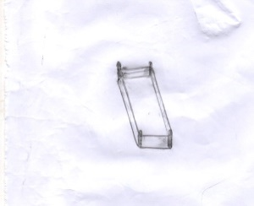
- Decide the size of the bed and put stakes to mark the each corner .

- If the soil is hard and dry , water the bed area with sprinkler and allow the water to seep down for at least two days ahead of the making of the bed .
- Use a fork to loosen the soil 12 inches deep . and remove all the grasses and weeds .
- Water lightly for one or two days to break the clods if they are big. Let the soil rest for one day.
- Start double digging :
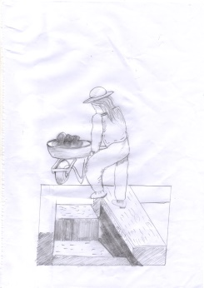
- Dig a trench of one foot wide and one foot deep on one side of the bed . Remove the soil and store it in a bucket .

- Loosen the soil in the trench and with the help of a fork and put the fork 12 inches and loosen the soil .
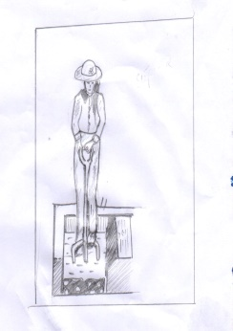
- Dig out the upper part of the second trench made in the bed adjacent to the first trench .Make the trench of one foot wide and one foot deep and spade out the loosened soil and put it in the upper part of the first trench. Try to mix the soil layer as less as possible . Microorganisms in soil live in different layers and less their living quarters are disturbed during digging the bed they will be more actively involved in providing nutrients to the plants .
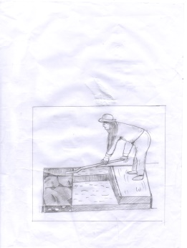
- Loosen the lower level of the second trench upto another 12 inches and move on doing the third trench and go on until the whole bed is covered .
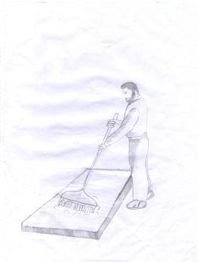
- The last trench might not require the soil fom the first trench as the breaking down of the compactness and making the soil more friable will increase the coverage of soil .

- After that rake the whole bed .

- Now with the help of bamboo or a wooden plank , make a six inches height walling of the raised bed .
- Put a layer of compost followed by a layer of top soil from the forest or the portion left between two beds .
- Put a thin layer of vermicompost followed by a layer of compost and the top soil .
- Sprinkle Amrit pani (Cowdung + Cow urine + Jaggery +water ) to the soil layer and ensure that you have made a 6 inches raised bed .
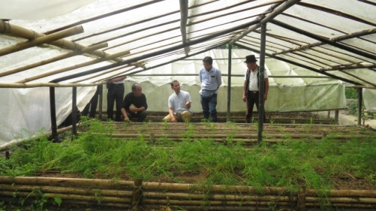
- At the top layer of the bed apply compost and start planting the plants and apply some vermicompost over them .
- Avoid recompaction by not moving around the beds by walking .
- The time required to make a bed for expert may be 1 – 2 hours but new people might need a whole day .
- You can also develop a bamboo frame and put UV stabilized films to transform it to a simple method of growing all season vegetables .
- Time to time application of compost tea or panchagavya or amritpani is required .

- Mulching with live mulch like local medicinal plants or mulch with straw or mulch film . You can even use micro irrigation systems on them like drip irrigation and sprinkler .
PLANTING ON RAISED BEDS :
Hexagonal spacing :
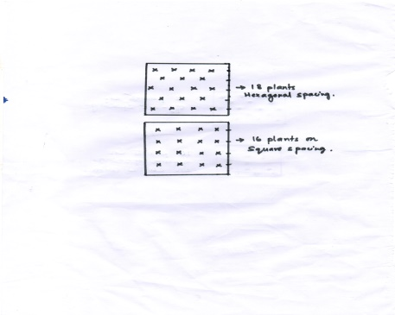
The best way to plant on raised beds is hexagonal spacing in which you can accommodate more plants. 10 percent more plants can be accommodate by this way of planting. If square spacing is given there will be certain free spaces which will result in compactness of those areas which is not desirable on raised beds. With hexagonal spacing the leaves will touch each other on all sides and will create a mini climate which is called “Living Mulch” which is very much needed in this era of water shortage.

Insect pest & Disease control in the raised beds :
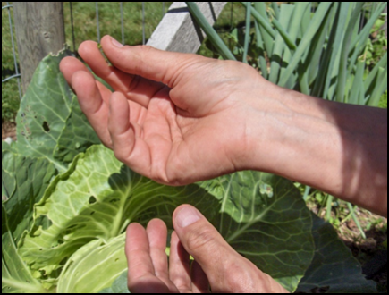
- To control soil insects like ants (during seed sowing as they take away the seeds) and red ants and termites , take a coconut shell or a plastic glass . Make some holes on the shell or the cups at the base on the sides and place some jaggery on the shell or the glass and place them on different places on the bed . Time to time remove the ants that come inside the shell and the cup. They get busy with the piece of jaggery and the seeds are saved .
- Regular monitoring and hand pricking.
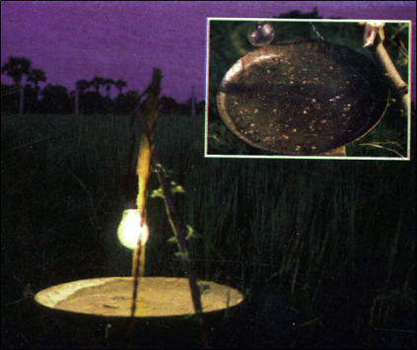
- Use a light trap in the garden from evening when the darkness starts uptill 8 pm . Do not put beyond 8 pm as beneficial insect’s moths may also be trapped.

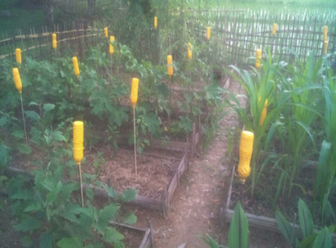
- Reuse a mineral water bottle to make a yellow trap . Colour the bottle with yellow colour and put some sticky material on it like some castor oil . Put the inverted bottle on a bamboo stick and install them at crop height in the raised beds. It has a very effective control against sucking insects like aphids and white flies . It also attracts fruit flies on gourds . Yellow colour tins or plastic bags can be also reused.

- Mix raw cowdung with neem leaves and castor leaves and make the cowdung into cakes and dry in shade . The dry cowdung cakes should be burnt in the beds to fumigate in the evening . The ash can be sprinkled over the bed as fungicide .
- Follow crop rotation practice in the bed and making permanent raised beds make it easy to rotate the crops . For example rotating groundnut with maize will reduce the attack of white grubs. Rotating pigeon pea or chickpea with other non-leguminous crops help to control fusarium-wilt and nematode problems.
- Use of trap crops like the marigold in the bed. Insects are strongly attracted to certain plants and when these are planted along the border they will gather them rather than on the border . Later they can be easily destroyed .
- Mustard is a trap crop along with cabbage for the control of Diamond back moth , aphids and leaf miners. Maize plants are trap for fruit flies of vegetables .
- Intercropping also adds to pest control as insects find difficult to locate the host plants . Even chemical stimuli for the host plant is not so strong and aromatic odours of other plants can disrupt the insect’s ability to locate such host plants .For example cabbage intercropped with carrots and tomatoes is a good strategy to control diamond back moth .Green gram intercropped with sugarcane reduces the incidence of Sugarcane early shoot borer .
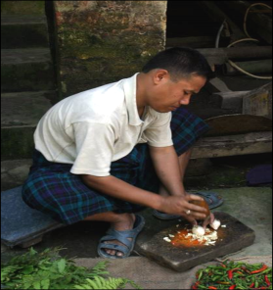
- Always preference given to local varieties of crops is a good strategy to have less insect and disease incidence in the beds as most of them are resistant to those problems .
- Botanical extracts like the five leaf extract , ginger-garlic-chilli extract , Neem seed kernel extract etc can be used in pest and disease control .

- Feed the soil well with compost , vermicompost and other liquid formulas like panchagavya , amrit pani etc are good to make the plant strong to resist insect and disease attacks . So Raised Biointensive beds are the best control for soil borne diseases.
- Cow urine based sprays can reduce the incidence of diseases in the raised beds.
- A variety of weeds which have pesticidal properties are used to make liquid manure mixed with animal dung can be very effective in pest control and nutrient management in the beds.

References :
- The Sustainable Vegetable Garden : John Jeavons and Carol Cox .
- A Guide Book to maintain Healthy Garden Soil and Better Yield : Preparing Bio Intensive Raised Beds by Samir R Bordoloi .

For Further details :
Samir Bordoloi
Head , Knowledge division ,
Farm2Food Foundation , Assam , India
Email : samirf2f@gmail.com
Mobile No: 08486029583
Website : www.farm2food.org

